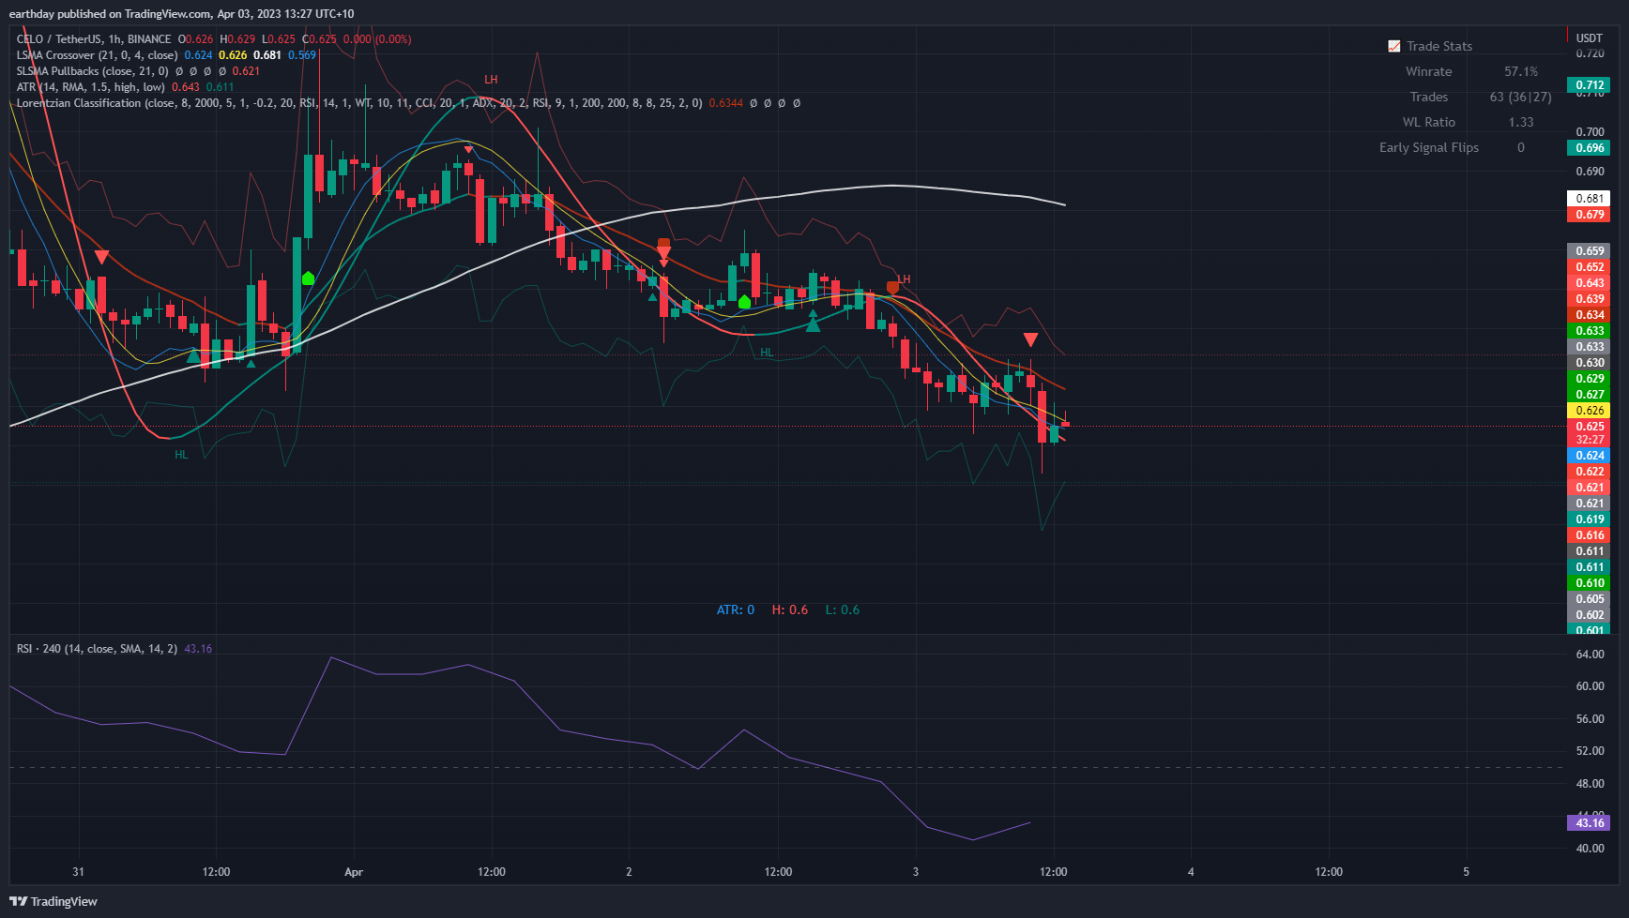

Indicators:

LSMA Crossover (by Veryfid)

SLSMA Pullbacks (by Veryfid)

Lorentzian Classification (type Machine Learning into ‘Indicators’ in TradingView, by jdhorty)

ATR Stop Loss Finder (by Veryfid)

RSI (by TradingView)

**Other criteria – be able to:**

Set Risk/Reward

Enter Short Only/Long Only

Option of Selecting Exit Type

1. ATR
2. Price touches the regression line (referred to as a Kernel) within the Lorentzian Classification Indicator
3. LSMA crossover

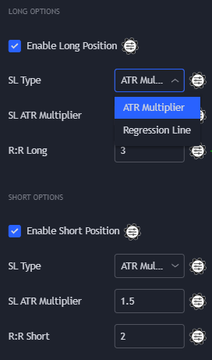

1. Change of colour in Lorentzian regression line (Kernel) or SLSMA regression line (See image below)
2. An opposite signal (long/short) is generated for either the Lorentzian Classification, or SLSMA Pullbacks indicators (See image below)

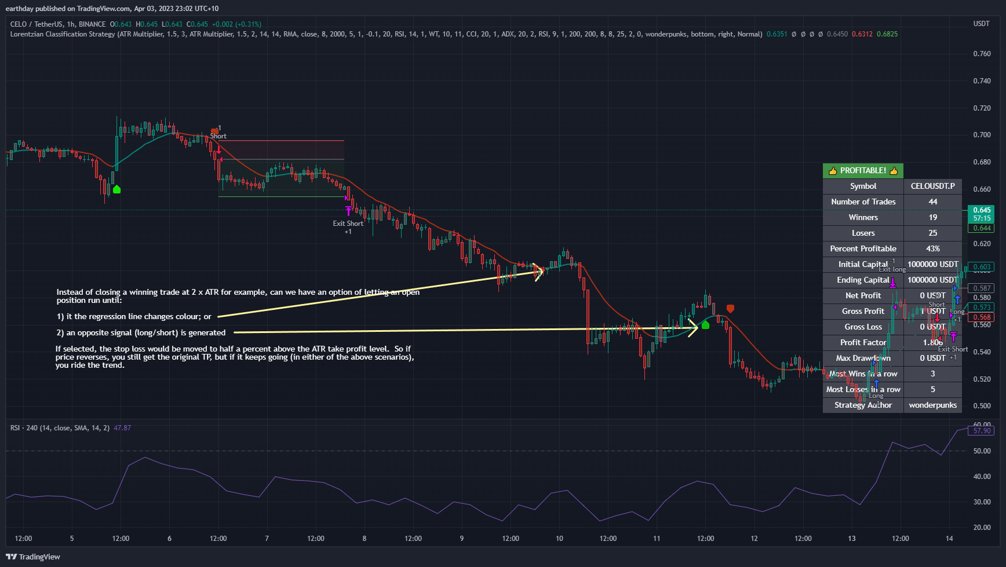

Set a maximum SL or minimum TP % – so if I only wanted to risk 4% in a trade, it wouldn’t take a trade if the ATR showed a stop loss of 8%

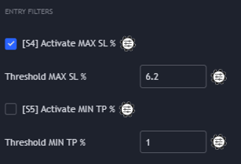

Have the following parameters for RSI. I use a 4 hour RSI timeframe on a 1 hour chart. Can you also add LSMA as an MA type in the ‘MA Type’ field.

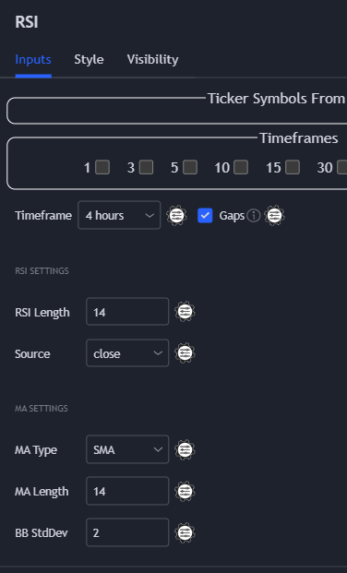

Miscellaneous

Be able to run backtests, and adjust parameters to see the impact on the backtested results (e.g. winrate, P&L, drawdown etc)

SLSMA Pullbacks has smaller arrows and larger arrows – I’m only trading the larger arrows.